GGosp
Gospel Trumpet

Grace Chapel Community Church ~ September, 2014 ~ Edition 1 Volume 2

Just Do It!!!

Do not merely listen to the word, and so deceive yourselves. Do what it says. ~ James 1:22

Do not merely listen to the Word

It is not enough for us to hear the word. If so, Christianity would be absolutely thriving. As Christians we already know more of the Bible than we are living. A good portion of us have been raised in the Church, heard great sermons, and have been a part of a small group study and / or Sunday school class.

If, by chance you were not raised in the Church and you are a believer in Jesus Christ there is still a really good chance that you have heard from the word of God enough to know that you know more about what it says than what you are living.

Our problem as believers does not tend to be that we are not listening to the word of God, but that we are doing very little with what we have heard. Just to be clear, listening to the Word of God includes our personal time in God’s Word and prayer. Whether we are hearing a lesson being taught, or a sermon being preached, or reading from God’s word on our own, God is speaking to us. In these moments we need to ask ourselves whether we are merely listening to words, or whether we are listening to the small still voice of God.

Many of us as believers mark our Bibles, with notes, underlining passages, and high lighting verses, the question we need to be asking is the Bible leaving its mark on my life and how it is being lived.

By doing so you would deceive yourself.

If all we are doing is listening to the Word God we are missing the mark on what God intends to do through Scripture. One of the objectives of a Holy Bible is to produce a Holy life. A holy life can only be realized as we learn to put into practice God’s Holy Word.

We deceive ourselves when we listen to the Word of God and believe that in some way it is what God desires for His people. God doesn’t want you to simply listen to a message. He wants you to become the message. If you think you are becoming spiritual because you have heard from the Word of God, you are kidding yourself.

Do what the Word of God says!!!

As we hear God speak through Scripture and He brings points of application to our thoughts we need to do what God is calling us to do. When we are engaged in Bible Study, hear a sermon, or reading the Bible for ourselves, we need to be asking what is God saying to me from His Word and how can I apply this truth to my life and how it is being lived.

My prayer for each of us is that we would be sensitive to what God is saying to us from His word and what it means for our lives, and how we might apply His truth to the life that we are living.

Serving Our Lord Daily

Pastor Louie Pantelis

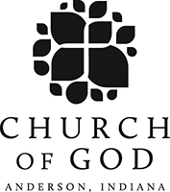
Starting Sunday evening 10/12 @ 6:00 pm we will be starting a small group that will focus on who we are as a part of the Church of God.

Grace Chapel Community Church is a part of the Church of God Reformation movement with offices in Anderson, Indiana. Our small group will focus on what it means for us to be a part of the Church of God and how we can become more engaged with what God is doing through our Church movement in our communities, state, and world.

Multi-media training

When: Saturday 9/27 from 9:00 AM to 11:00 AM
Donuts & coffee will be provided.

Where: Grace Chapel Sanctuary

We are seeing a greater need for volunteers who are able to work with multi-media (Easy Worship / Powerpoint) for our Church. Many have said they would help but they do not know anything about these programs or how to use them.

During this training event Pastor Louie will be training whoever is willing to learn. He will walk you through how we use Easy Worship in our worship services, how to put a service together with easy worship, and how to utilize Easy Worship during a worship service. He will show you how to create a powerpoint presentation for announcements, studies, etc… Join us for this training and become a part of the team.
We need nursery workers in our nursery. Your serving in this way enables a mother or father to be ministered too. Please see Michelle Emmett.

We are looking for persons willing to help cook meals on Thursday evenings before Thursday Church.

Care meals are a means to put love into action. We provide these meals for members in our Church who have gone through a surgery, have had a baby, lost a loved one, or are sick. If you could help, please contact Tammy Decroo or Ruth Dugger.
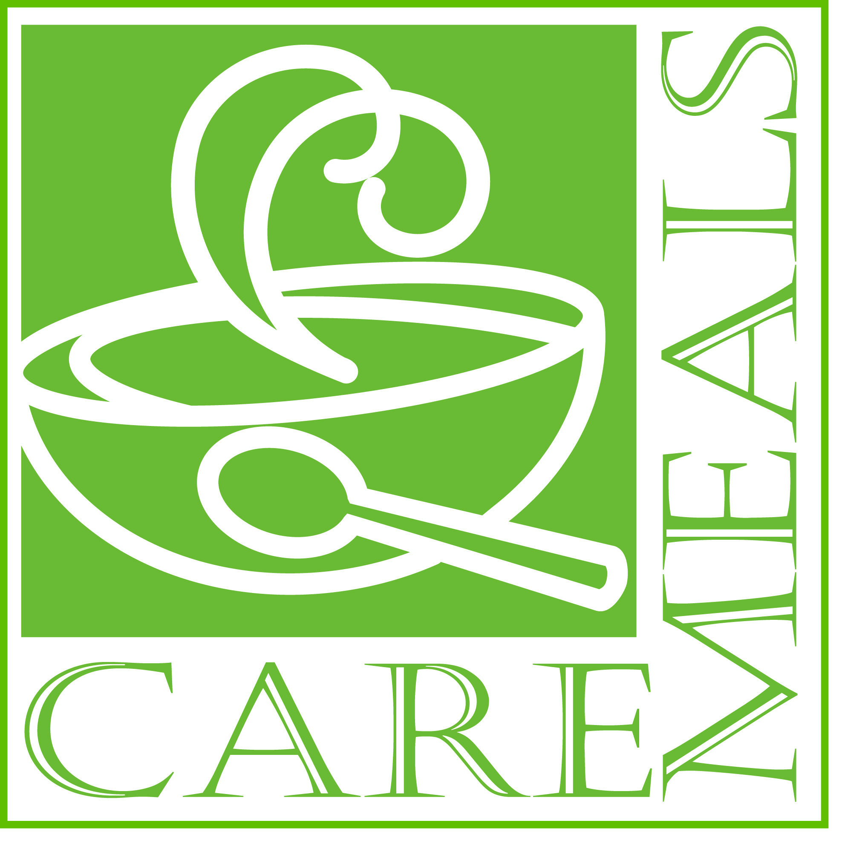

On the hills outside of Bethlehem, a family of inquisitive, energetic shepherds discovers the meaning of being part of the “royal dynasty” that will one day produce a new king for their people. As they explore what the prophets said would happen in “boring Bethlehem,” they become part of the story unfolding on the night Jesus was born. They learn that even though you may have to wait to see it happen, God always keeps His promises. And in the end, they realize that every one of us is invited to be part of a dynasty – God's great family which we join when we believe in His Son. Our Children will be major contributors in this production, so we need them here on Sunday mornings. We will also need adult volunteers, please see Heather Campbell for more details. The program will be December, at 6:00 PM.

